**Assignment 6**

**Use Group by clause with appropriate sql functions to solve following queries.**

**Note : To solve below queries use “hr” database**

1. Display manager ID and number of employees managed by the manager.

**select manager_id,count(EMPLOYEE_ID) from employees group by manager_id;**

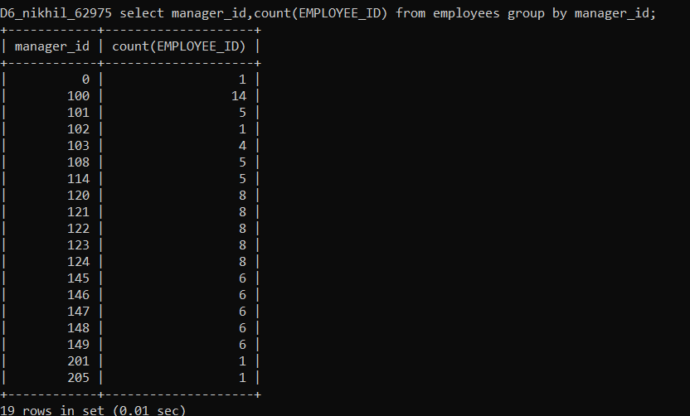

1. Display the country ID and number of cities we have in the country.

**select country_id,count(city) as city from locations group by country_id;**

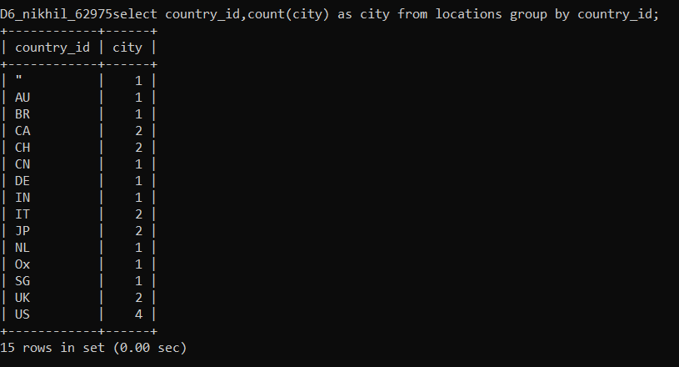

1. Display average salary of employees in each department who have commission percentage.

**select DEPARTMENT_ID,avg(salary+commission_pct) as avg_salary from employees where commission_pct>0 group by DEPARTMENT_ID;** 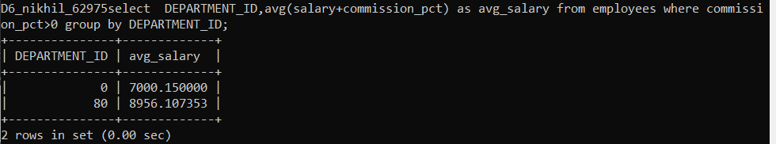

1. Display job ID, number of employees, sum of salary, and difference between highest salary and lowest salary of the employees of the job.

**select job_id,sum(salary) as Sum,count(*)as no_of_employees,max(salary)-min(salary) as diffsal from employees group by job_id;**

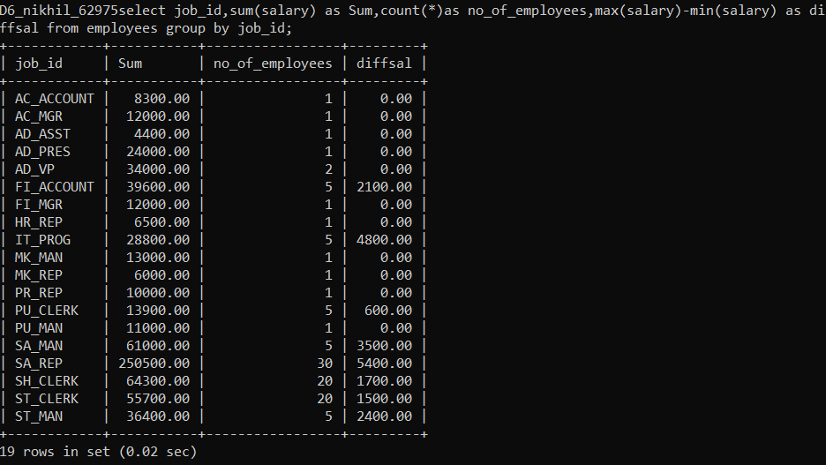

1. Display job ID for jobs with average salary more than 10000.

**select job_id,avg(salary+commission_pct) as avg_salary from employees group by job_id having avg(salary+commission_pct)>10000;**

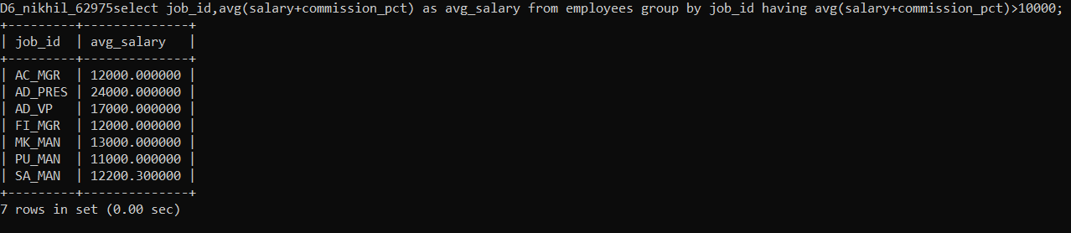

1. Display years in which more than 10 employees joined.

**select year(hire_date) as year,count(*) as no_of_employees from employees group by year having no_of_employees>10;**

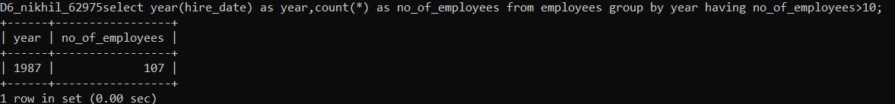

1. Display departments in which more than five employees have commission percentage.

**select department_id,count(commission_pct) as comm from employees where commission_pct>0 group by department_id;** 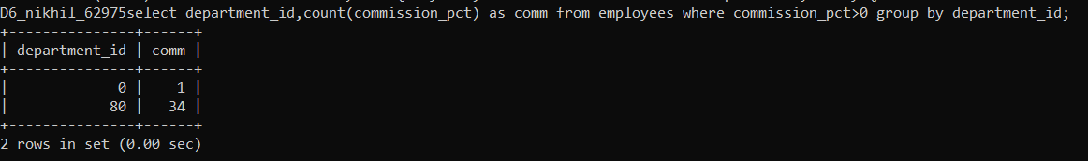

1. Display employee ID for employees who did more than one job in the past.

**select employee_id,count(*) as noofjobs from job_history group by employee_id having noofjobs>1;**

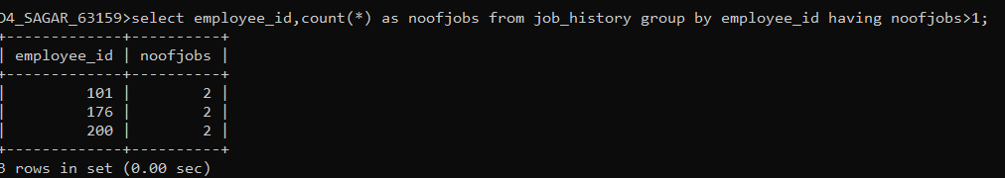

1. Display job ID of jobs that were done by more than 3 employees for more than 100 days.

**select job_id,count(*) as noofemployees from employees where datediff(now(),hire_date)>100 group by job_id having count(*)>3;**

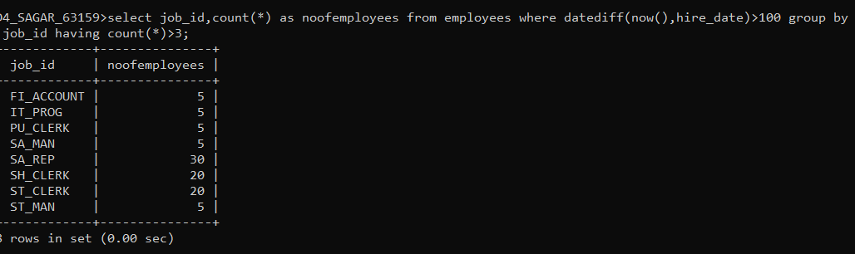

1. Display department ID, year, and Number of employees joined.

**select department_id,year(hire_date) as year ,count(*) as noofemployees from employees group by department_id,year;**

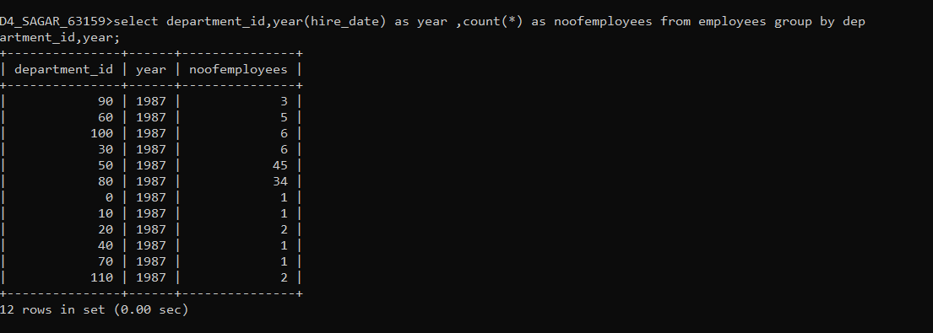

1. Display how many employees joined in each month of the current year.

**select month(hire_date) as month,count(*) as no_of_employees from employees group by month;**

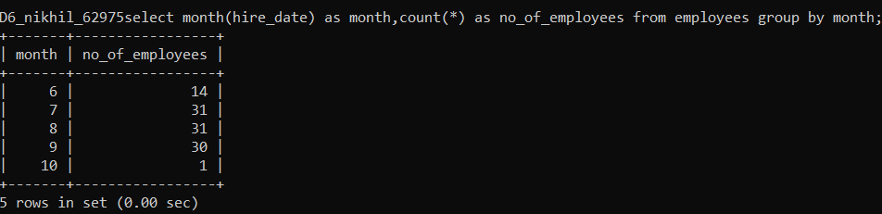

1. Display details of departments in which the maximum salary is more than 10000

**select department_id,max(salary) as max_salary from employees group by department_id having max_salary>10000;**

